Photo by [Matt & Chris Pua](https://unsplash.com/@pua_photos?utm_source=unsplash&utm_medium=referral&utm_content=creditCopyText) on [Unsplash](https://unsplash.com/s/photos/rain-jacket?utm_source=unsplash&utm_medium=referral&utm_content=creditCopyText)

Photo by [KAL VISUALS](https://unsplash.com/@kalvisuals?utm_source=unsplash&utm_medium=referral&utm_content=creditCopyText) on [Unsplash](https://unsplash.com/s/photos/rain-jacket?utm_source=unsplash&utm_medium=referral&utm_content=creditCopyText)

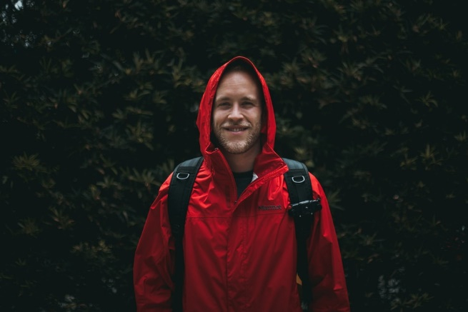

Photo by [KAL VISUALS](https://unsplash.com/@kalvisuals?utm_source=unsplash&utm_medium=referral&utm_content=creditCopyText) on [Unsplash](https://unsplash.com/s/photos/rain-jacket?utm_source=unsplash&utm_medium=referral&utm_content=creditCopyText)

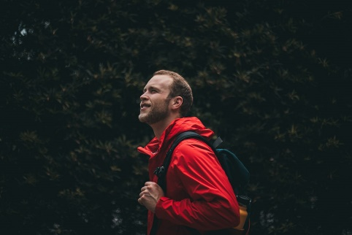

Photo by [Caleb Kastein](https://unsplash.com/@cjkastein?utm_source=unsplash&utm_medium=referral&utm_content=creditCopyText) on [Unsplash](https://unsplash.com/s/photos/rain-jacket?utm_source=unsplash&utm_medium=referral&utm_content=creditCopyText)

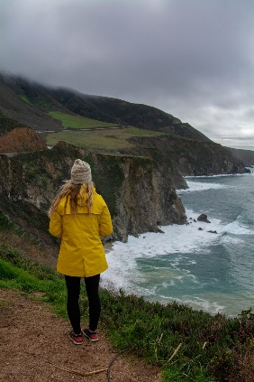

Photo by [Dim Hou](https://unsplash.com/@dimhou?utm_source=unsplash&utm_medium=referral&utm_content=creditCopyText) on [Unsplash](https://unsplash.com/s/photos/rain-jacket?utm_source=unsplash&utm_medium=referral&utm_content=creditCopyText)

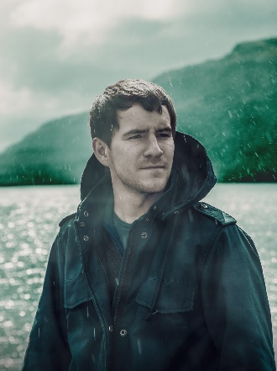

Photo by [Max Ducourneau](https://unsplash.com/@maxdcrn?utm_source=unsplash&utm_medium=referral&utm_content=creditCopyText) on [Unsplash](https://unsplash.com/s/photos/rain-jacket?utm_source=unsplash&utm_medium=referral&utm_content=creditCopyText)

